

**Gantt Chart Submission**

Project Management



May 7, 2020

Submission from:

Naeem Ali (13292) & M. Iftikhar Uddin Khan Sami (13275)

Contents

Gantt chart: 1

Task’s List: 2

Project Timeline: 3

Resource Sheet: 4

Gantt chart Link – Ms-Project File: 4

# Gantt chart:

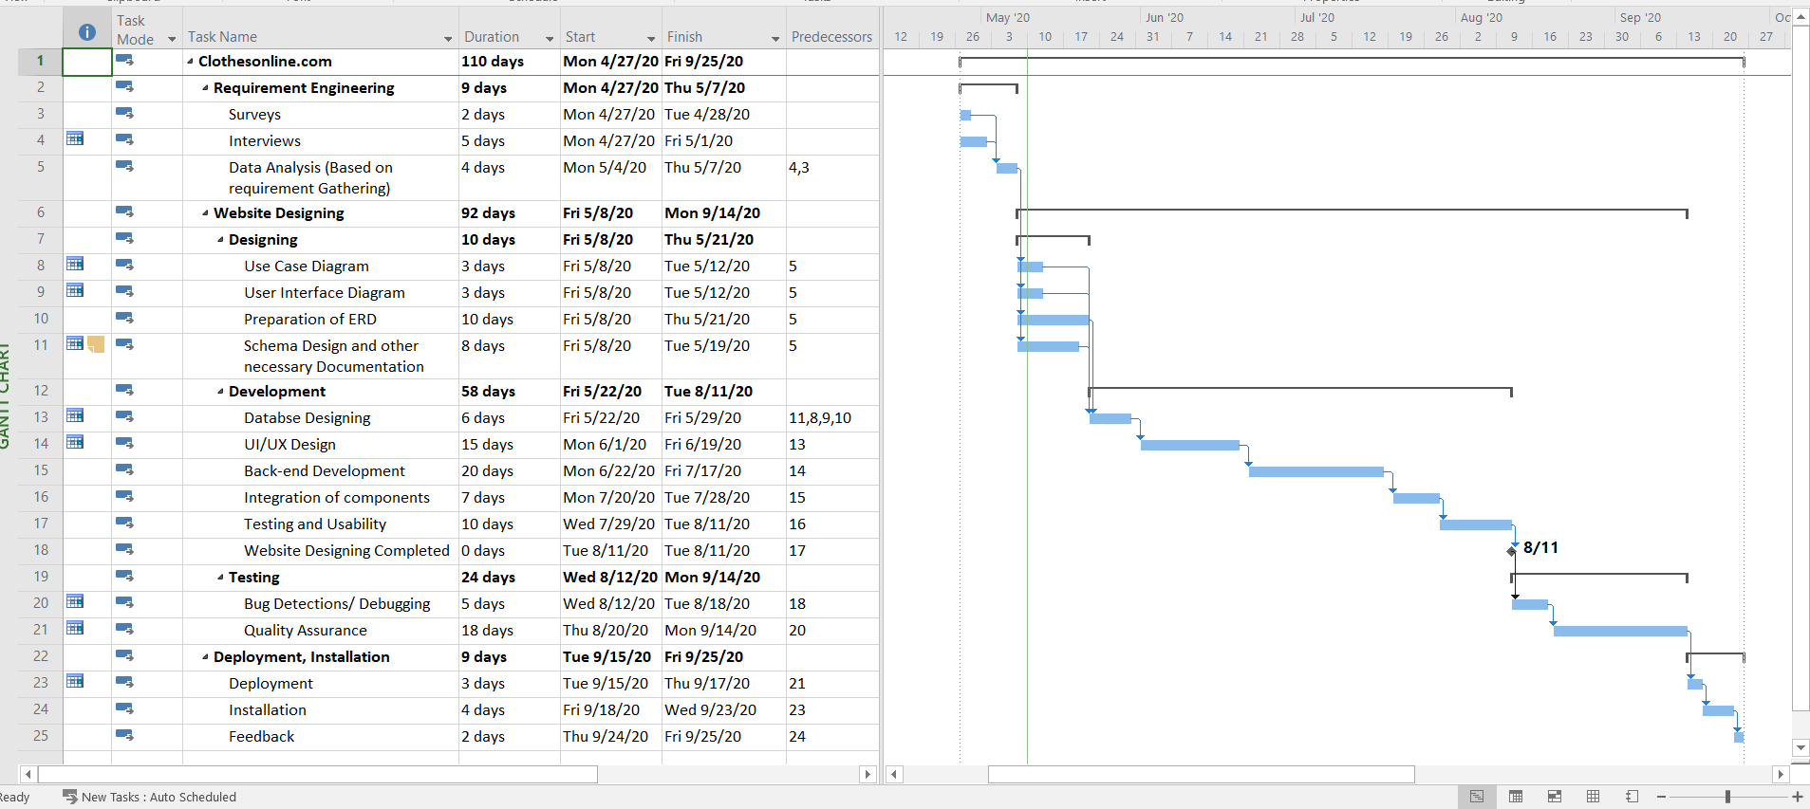

# Task’s List:

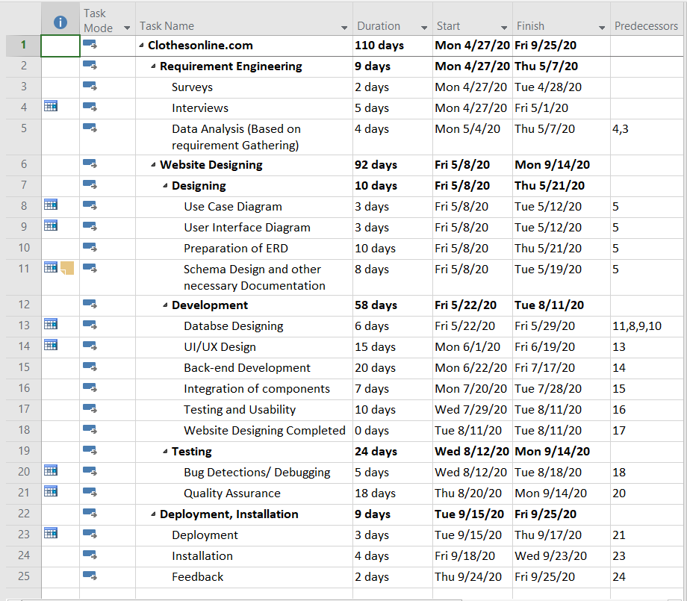

# Project Timeline:

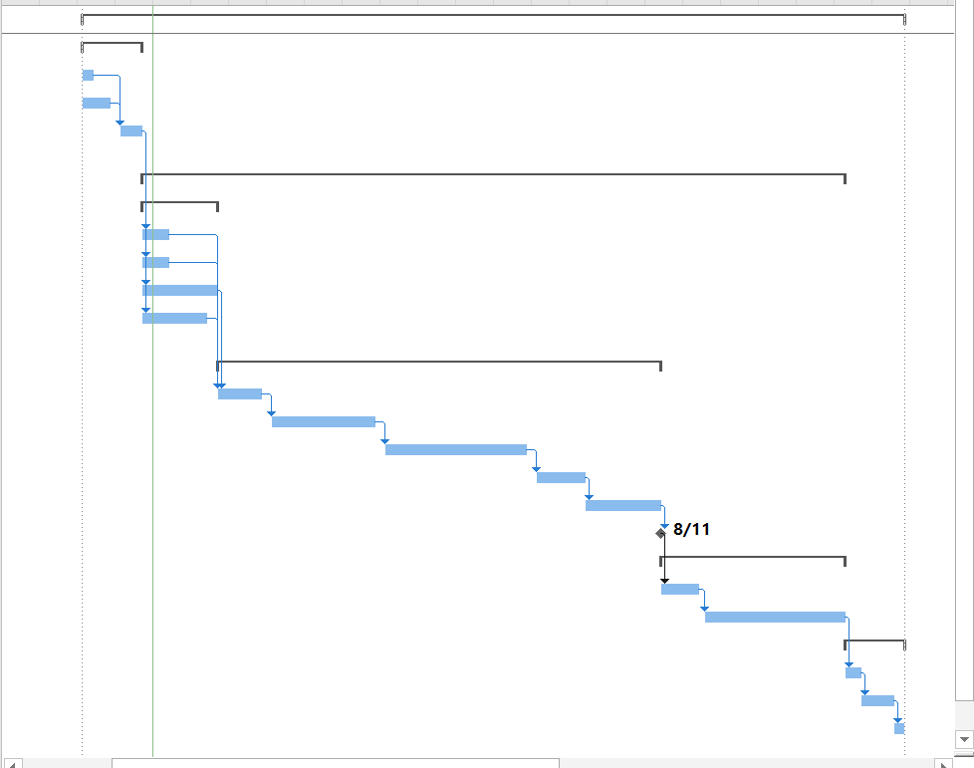

# Resource Sheet:

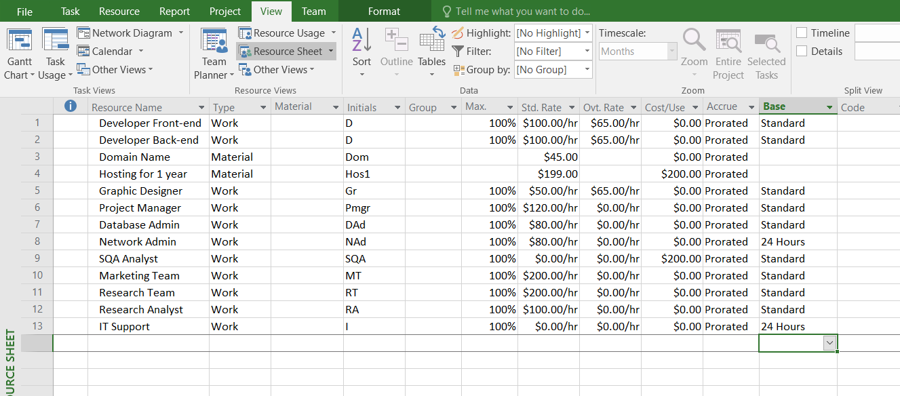

# Gantt chart Link – Ms-Project File:

https://drive.google.com/open?id=1zj-hAPnOBztwBCFsAj-Ess5hFcxkDkXH